Name: Alhassan Attayeb Ali Abdul Razzaq Alhadidi.
ID: 202311191
Instructor: Dr. Majdi Salama.
Subject: Computer Organization and Architecture.
Section: 2.
Project name: Multi-Criteria Alarm and Priority Pulsing System (MCAPPS).

This system highlights three main functions:
1. Multi-Criteria: Refers to processing five different conditions (temperature, humidity, gas, proximity, and tilt).

2. Alarm: The system's primary function.

3. Priority Pulsing: Refers to advanced logic that identifies the highest risk and then displays it in intermittent pulses (1 second on/1 second off).

To avoid the lack of GND and 5V ports from Arduino UNO, We should:
●put the GND port on the far lower right side of the white board, specifically on the (-) side, which is located opposite j-30, and (-) side is between of them.
●put the 5V port on the far lower left side of the white board, specifically on the (+) side, which is located opposite a-30, and (-) side is between of them.

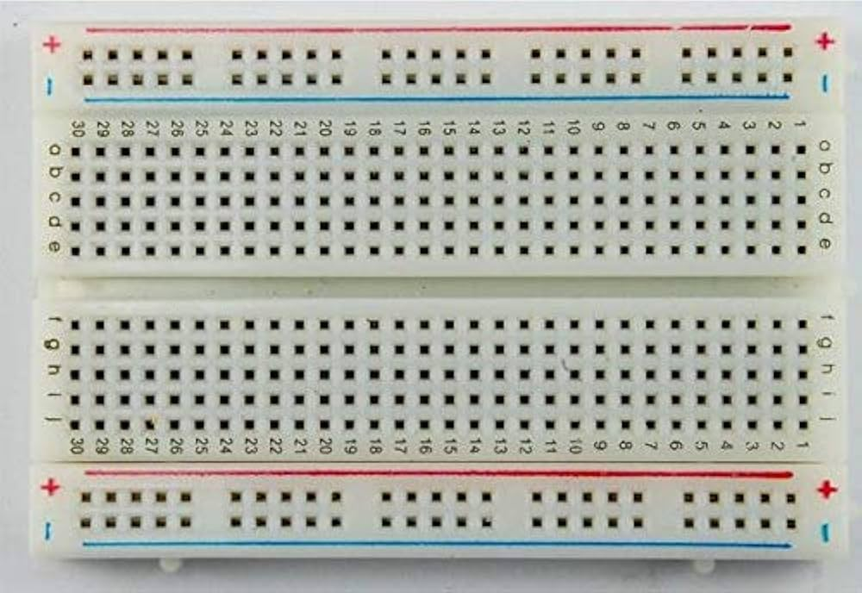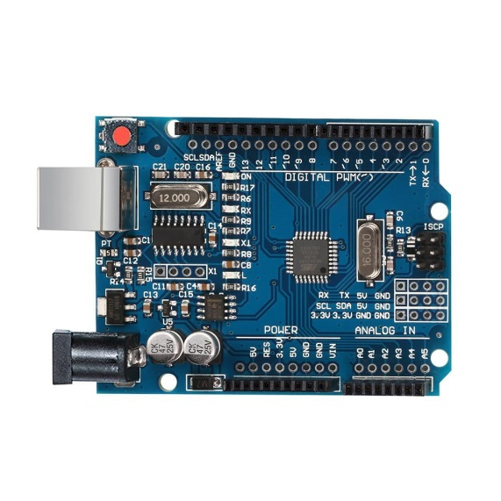
GND
5V

●The system contains 4 sensors for input and 2 units for outputs, which are:

1-Input Sensors:
1. Gas Sensor (MQ Series): Measures Gas particles (Analog value), and contains 4 pins: AO (Analog output), DO (Digital output, Which isn’t used), GND (Ground) and VCC (Voltage at the Collector-Collector).
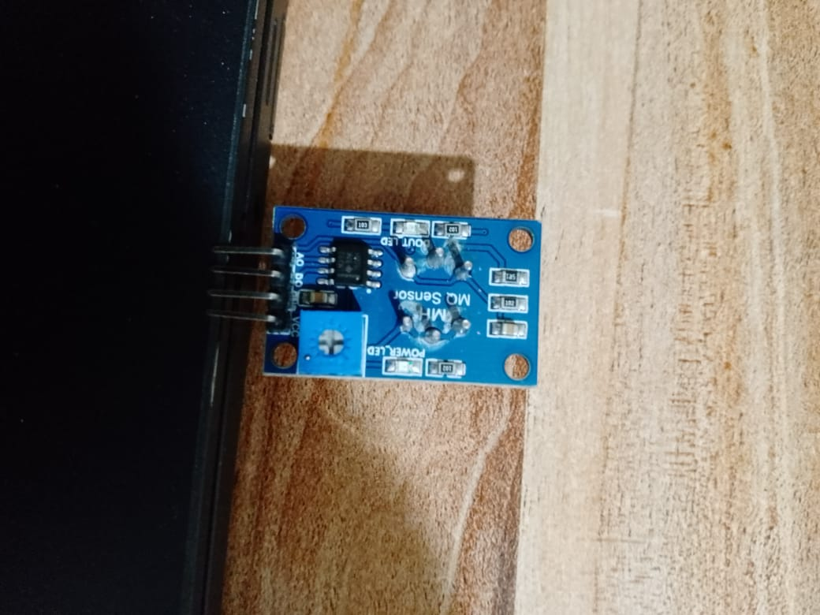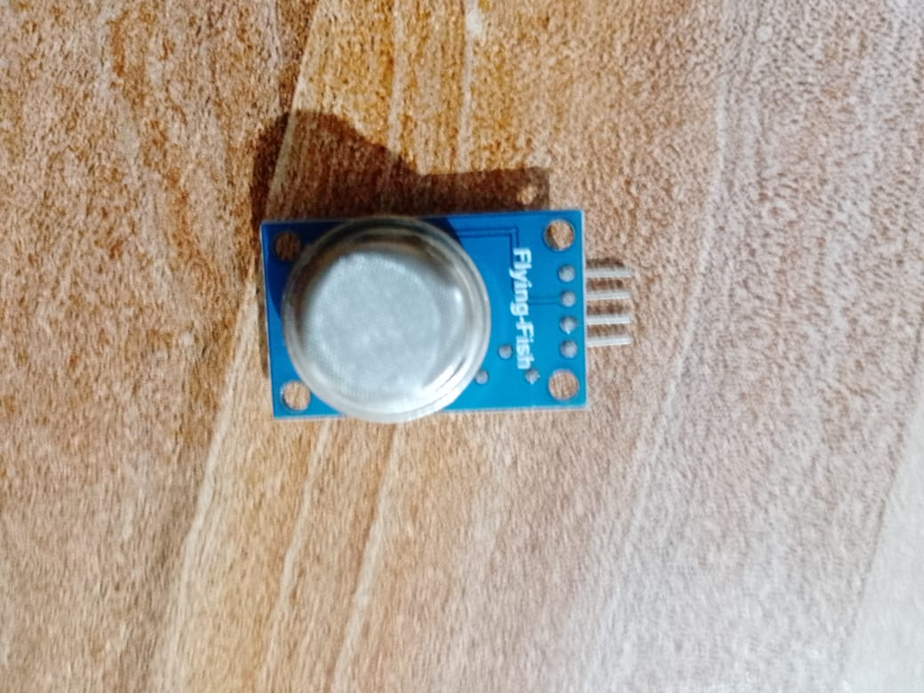

GND
5V
A0

(A0, GND and 5V) on Arduino UNO.

2. DHT11 Sensor: Measures Temperature and Humidity, and contains 3 pins: S (Signal pin, also known as Output pin), VCC and (-) (GND) pin.
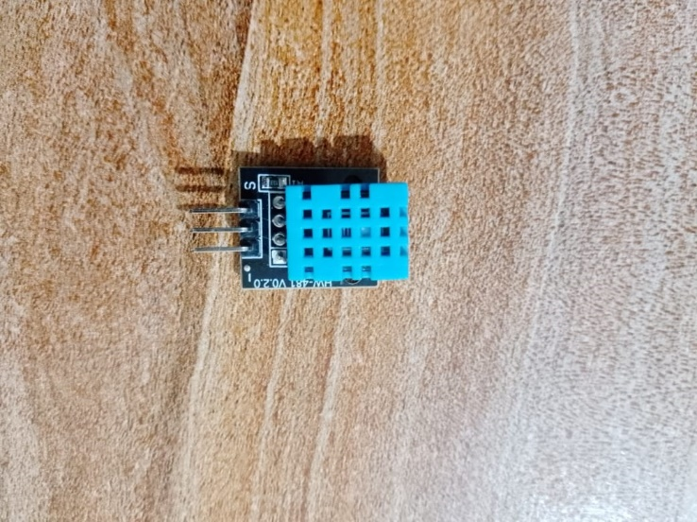
D8
5V
GND

(D8, GND and 5V) on Arduino UNO.

3. IR Sensor (Infrared Proximity): Detects nearby objects/obstacles, and contains 4 pins: EN pin(Enable, which isn’t used), VCC pin, OUT pin and GND pin.
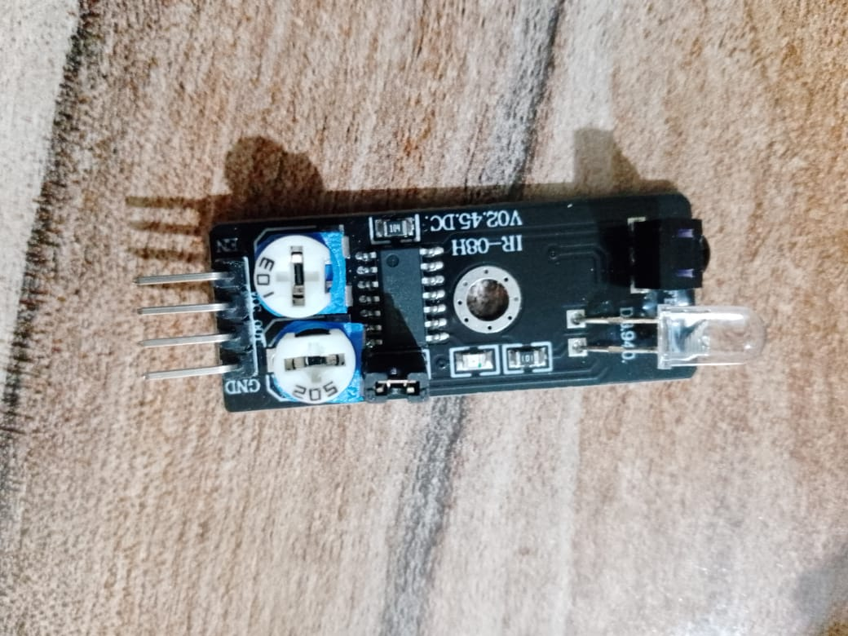
GND
D12
5V

(D12, GND and 5V) on Arduino UNO.

4. Vibration Sensor: Detects physical tampering or movement, and contains 3 pins: GND pin, VCC pin and S pin (Single).
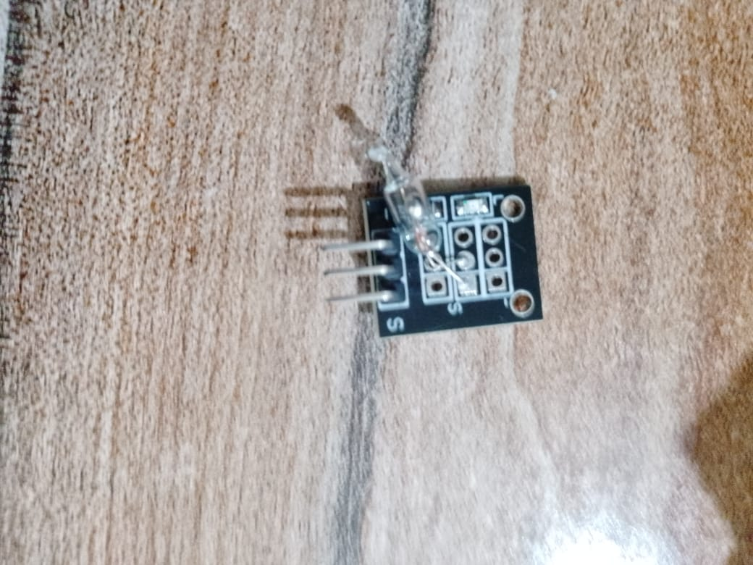
D7
GND
5V

(D7, GND and 5V) on Arduino UNO.

2-Output Units:

1. Buzzer: Audible Alarm Output, and contains 3 pins: (-) (GND) pin, VCC pin and S (Single) pin.
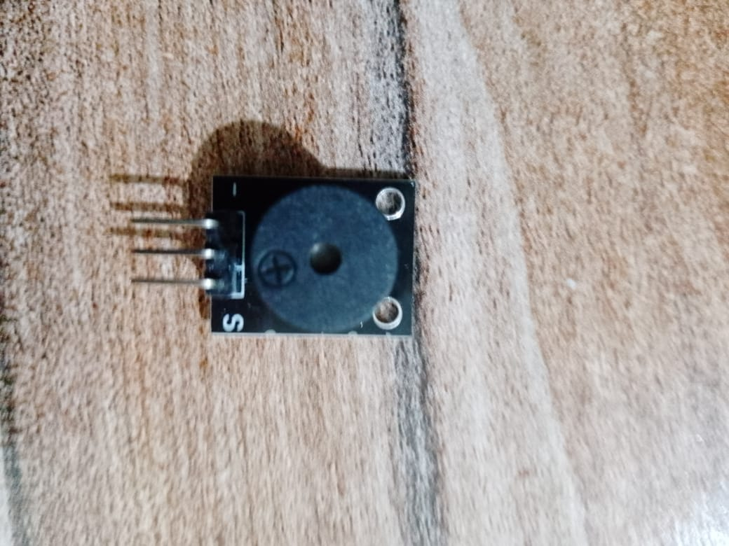
D2
5V
GND
(D7, GND and 5V) on Arduino UNO.

2. RGB LED: Visual Alarm Output (Displays the priority color: Red, Purple, Yellow, Green, or Blue), and contains 4 pins: R (Red) pin, G (Green) pin, B (Blu) pin and GND pin.
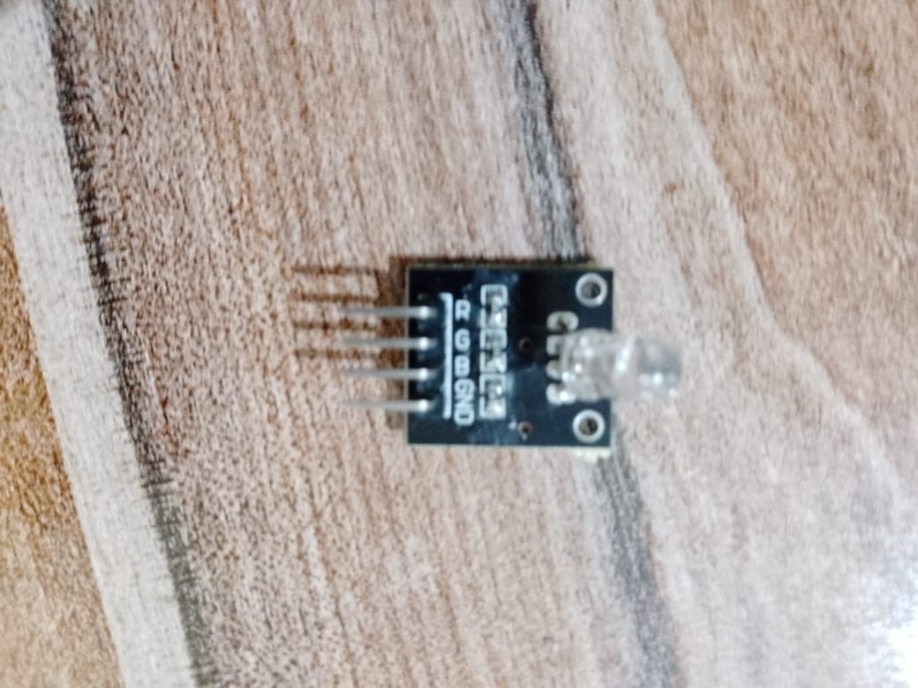
GND
D11 ~
D9 ~
D10~ ~
(D9~, D10~, D11~ and GND) on Arduino UNO.

●Advanced Code Logic and Troubleshooting Documentation:

1. Priority Matrix (The Decision Engine)
The system is designed to operate on a "Highest Priority First" principle, ensuring that only one specific alarm is active at any moment, even if multiple sensors are triggered simultaneously.
Priority Level | Condition | Activated Color
1 | Proximity (IR Sensor) | RED
2 | Tilt/Vibration | PURPLE
3 | Gas (MQ Sensor) | YELLOW
4 | Temperature | GREEN
5 | Humidity | BLUE

2. The Pulsing Logic (Stable Alarm Cycle)
A major challenge was preventing the system from spamming the serial monitor with repetitive messages (e.g., Alarm Pulse Ended (System in Standby)) and ensuring persistent threats are signaled clearly without causing system lockup. This was solved by implementing a defined time-based cycle using the millis() function:
- Total Alarm Cycle: 2000 milliseconds (2 seconds).
- PULSE ON Duration: 1000 milliseconds (1 second)—The LED and Buzzer are active.
- SILENT GAP Duration: 1000 milliseconds (1 second)—The LED and Buzzer are off, allowing the system to reset and verify the condition before the next pulse begins.

3. Hardware Troubleshooting and Code Fixes
The final code incorporates critical adjustments to account for non-standard or unexpected sensor behavior encountered during initial testing:
Issue Encountered | Initial Reading/Cause | Solution Implemented in Code
IR Proximity Issue | The sensor read 1 (HIGH) when nothing was present (safe state). | The detection logic was inverted: the alarm is now triggered when the reading is LOW (irStatus == LOW).
Gas Sensor Issue | Sensor read a persistently high value of 1002, preventing system stability. This was caused by an initial incorrect pin connection. | After correcting the wiring to the AO (Analog Output) pin, the baseline reading was confirmed at 48. The operational threshold was set to 400 in the final code.
System Loop/Spamming | The anyAlarmCondition remained perpetually true due to stuck sensors, leading to continuous serial output. | The Pulsing Logic was implemented, forcing a 1-second silent gap in the output cycle, which eliminated the repetitive messages and ensured system stability.

Unit/Sensor | Pin Type | Arduino Pin | Function | Priority Level
Buzzer | Digital | D2 | Audible Alarm Output | N/A
DHT11 | Digital (Data) | D3 | Input for Temperature/Humidity | P4/P5
Vibration/Tilt Sensor | Digital (Signal) | D7 | Input for Tampering/Movement | P2 (PURPLE)
RGB LED (Blue) | Analog (PWM) | D9 | Visual Alarm Output (Humidity) | P5 (BLUE)
RGB LED (Green) | Analog (PWM) | D10 | Visual Alarm Output (Temperature) | P4 (GREEN)
RGB LED (Red) | Analog (PWM) | D11 | Visual Alarm Output (Highest Priority Color Mix) | P1/P2/P3
IR Proximity Sensor | Digital (Signal) | D12 | Input for Obstruction/Intrusion | P1 (RED)
Gas Sensor (MQ Series) | Analog (AO) | A0 | Input for Gas Leak Detection | P3 (YELLOW)

Note: The priority works only on input sensors, the output units make the output for every sensor input depending on priority.

